Bike Sharing Demand

Bike sharing systems are a means of renting bicycles where the process of obtaining membership, rental, and bike return is automated via a network of kiosk locations throughout a city. Using these systems, people are able rent a bike from a one location and return it to a different place on an as-needed basis. Currently, there are over 500 bike-sharing programs around the world.

The data generated by these systems makes them attractive for researchers because the duration of travel, departure location, arrival location, and time elapsed is explicitly recorded. Bike sharing systems therefore function as a sensor network, which can be used for studying mobility in a city. In this competition, participants are asked to combine historical usage patterns with weather data in order to forecast bike rental demand in a city.

You must predict the total count of bikes rented during each hour covered by the test set, using only information available prior to the rental period.

**Data Fields**

**datetime** - hourly date + timestamp    
**season** -  1 = spring, 2 = summer, 3 = fall, 4 = winter   
**holiday** - whether the day is considered a holiday  
**workingday** - whether the day is neither a weekend nor holiday  
**weather** - 1: Clear, Few clouds, Partly cloudy, Partly cloudy   
2: Mist + Cloudy, Mist + Broken clouds, Mist + Few clouds, Mist   
3: Light Snow, Light Rain + Thunderstorm + Scattered clouds, Light Rain + Scattered clouds   
4: Heavy Rain + Ice Pallets + Thunderstorm + Mist, Snow + Fog   
**temp** - temperature in Celsius  
**atemp** - "feels like" temperature in Celsius  
**humidity** - relative humidity  
**windspeed** - wind speed  
**casual** - number of non-registered user rentals initiated  
**registered** - number of registered user rentals initiated  
**count** - number of total rentals

**Evaluation**

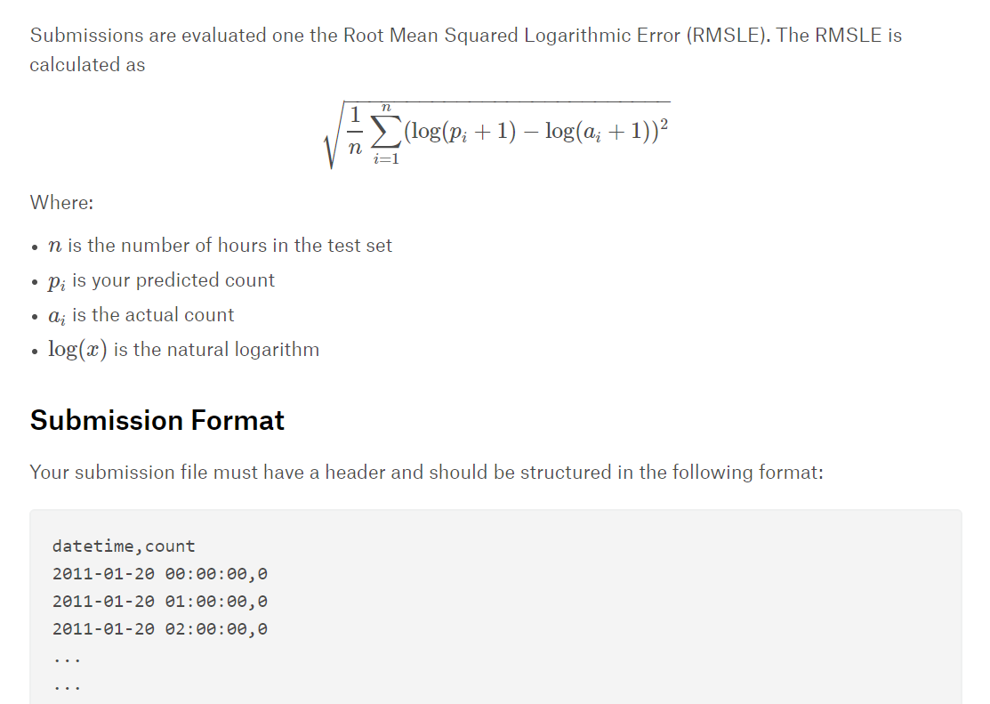

**Rules**

### One account per participant

You cannot sign up to Kaggle from multiple accounts and therefore you cannot submit from multiple accounts.

### No private sharing outside teams

Privately sharing code or data outside of teams is not permitted. It's okay to share code if made available to all participants on the forums.

### Team Mergers

Team mergers are allowed and can be performed by the team leader. In order to merge, the combined team must have a total submission count less than or equal to the maximum allowed as of the merge date. The maximum allowed is the number of submissions per day multiplied by the number of days the competition has been running.

### Team Limits

There is no maximum team size.

### Submission Limits

You may submit a maximum of 5 entries per day.

You may select up to 2 final submissions for judging.